

|  |
| --- |
| Master 203 in Financial Markets – Computational Finance |
| Quasi Monte Carlo pricing of path dependent basket options |
| To Kaiza Amouh |

|  |
| --- |
| Julien Baudin, Corentin Leblond  17th May 2020 |

Table of Contents

Introduction 3

User Guide 5

Inputs in Main.cpp 5

General Construction of a Monte Carlo Simulation for European Payoff 5

Construction of a Simulation for European Payoff with Variance Reduction techniques 7

Quasi Random Sequence 7

Antithetic Random Variable 7

Static Control Variate 8

Use Multiple Techniques 8

Case where the Covariance Matrix is not invertible 8

Results for European Payoff 9

No Variance Reduction 10

Quasi-Random Sequence 10

Antithetic Random Variable 14

Static Control Variate 15

Quasi Monte Carlo and Antithetic Random Variable 16

Quasi Monte Carlo and Control Variate 17

Control Variate and Antithetic Random Variable 17

Using All Three Techniques 18

Summary 18

American and Bermudan Options 19

Construction of a Simulation for path dependant Payoff with Variance Reduction techniques 19

The Longstaff-Schwartz approach 20

Path dependant exercice 20

Results for American and Bermudan Payoff 21

No variance reduction 22

Quasi Random Sequence 23

Van der Corput 23

Sobol 25

Quasi Monte Carlo and Antithetic Random Variable 25

Van der Corput 25

Sobol 27

Quasi Monte Carlo and Static Control Variate 28

Van der Corput 28

Sobol 29

Antithetic Random Variable 30

Static Control Variate 31

Static Control Variate and Antithetic Control Variable 32

Using all three techniques 33

Van Der Corput 33

Sobol 34

Increasing the number of polynomes 35

Conclusion 36

Going further? 36

References 37

# Introduction

According to the latest data from the BIS (Bank for International Settlement), the total amount (in $ notional equivalent) of derivatives contracts traded was around 640 Trillion for the first half of 2019. Derivatives serve mostly hedging, replication and arbitrage purposes for different actors that are the market makers, Institutionals but also retail investors. They are used for themselves or through structured products and funds. Pricing these products represent both an opportunity for sellers to be competitive but also a great risk. In that spirit, practitioners must be able to produce fast pricing as well as metrics to be able to gauge the accuracy of the price obtained. For vanilla products, the existence of close formulae gives an unbiased benchmark, and there is no question of accuracy. On the other hand, when considering less traditional contracts, such as path dependent option the lack of close formulae creates a need for both pricing techniques and the ability to assess the pricing accuracy of these models while being able to minimize the time of computation.

The following report is an attempt to answer part of that question. In the context of the master 203 in Financial Markets and the course of Computational Finance, this report will explore the Monte Carlo pricing of path dependent Basket options (in the case of Bermudan exercises and American). Pricing path dependent options can be done today with three main approaches. The binomial tree that is highly time consuming, the machine learning algorithm (for example through neural networks – a topic that has been explored in the Machine Learning project of the Master 203) and finally through the Monte Carlo approach.

The Monte Carlo technique relies on the Central Limit Theorem in the sense that for n independent and identically distributed (iid) experiences and when n is sufficiently high, the empirical mean of these experiences converges in law toward the true mean. Therefore, if one can simulate n different paths for the underlying index of a basket option, then one can estimate the final payoff at maturity (for the European case), averaging and discounting to get the price of such option. However, the variance among all simulated prices can be quite high which could make the price unreliable. That is why (in the risk perspective mentioned before), one has to estimate that empirical variance and if it is statistically possible build a confidence interval in order to find what would be the optimal number of simulations that will allow, for a given level of uncertainty, consider the price as a reliable one.

While finding the optimal number of simulations will be quite easy, this quantity can be very large meaning that the computation time will be quite long making its usage impossible in practice (no client would wait for two hours before having a price). Therefore, we will explore some variance reduction techniques in order to reduce the variance and the number of simulations needed to enter our confidence interval. One will implement:

* Low discrepancy random number generation (Van Der Corput and Sobol sequences)
* Static Control Variate approach
* Antithetic variable
* Mixing the three previous techniques

Finally, one will implement the Longstaff Schwartz approach to price path dependent options in the American and Bermudan framework.

To keep things standard, the framework will be a N dimensional Black Scholes diffusion where the d components of the Basket are (possibly) correlated. One will take constant covariance and correlation matrix, a constant and unique risk-free rate.

All computations will be done in C++.

# User Guide

Throughout this user guide, we display pieces of code to generate Monte Carlo simulations to value European and American basket call option. All the graphs and tables are obtained thanks to the code shown below.

## Inputs in Main.cpp

All numerical parameters for volatility, rate, time, correlation should be input in yearly values.

|  |  |
| --- | --- |
| **Variable Name** | **Description** |
| startTime | Starting point of the simulation in time |
| endTime | Ending point of the simulation in time |
| Nb_assets | Number of assets in the basket |
| Nbsteps | Number of time steps within each simulation |
| rate | Risk-free rate |
| K | Strike Price |
| Spot_vector | Initial spot vector |
| Sigma_vector | Volatility vector |
| Correl_mat | Correlation matrix |
| Weights_mat | How each asset weights in the basket |

We show an example of the above inputs:

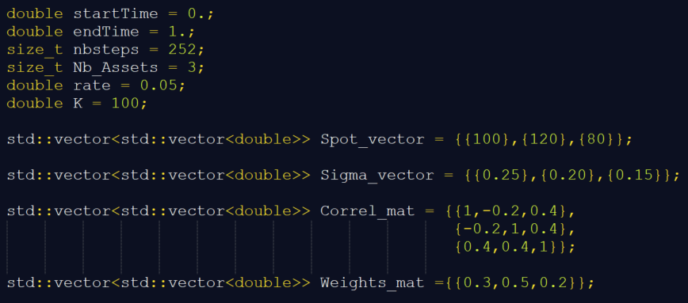

## General Construction of a Monte Carlo Simulation for European Payoff

In order to build the Monte Carlo simulation, one always needs at least to initialize the following objects:

* A uniform generator
* A normal generator
* A gaussian vector
* A random process
* A payoff
* A Monte Carlo object finally

We show an example of how to build all the above objects to run a standard pricing:

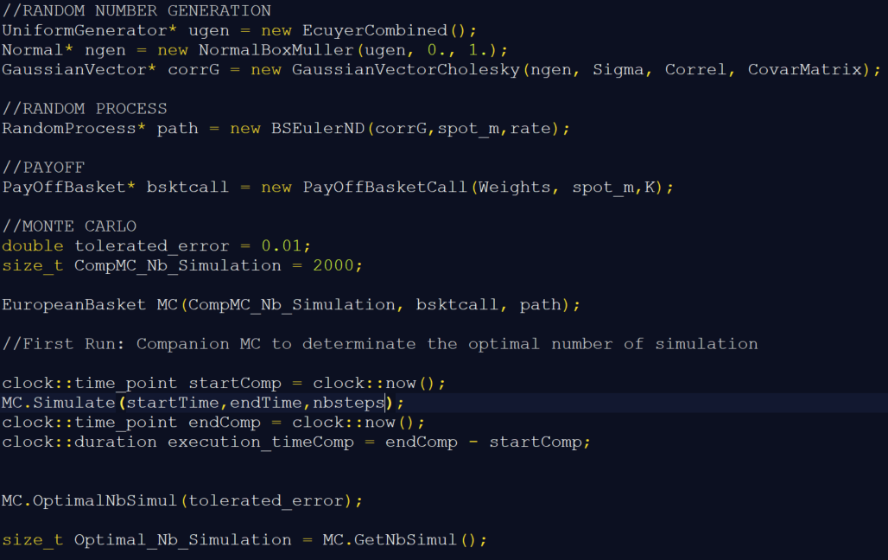

In the above example, we show the steps to run a first Monte Carlo simulation that is used to estimate the minimum number of simulations required to make the price enter into a 99% confidence interval with an error defined by the user (here 0.01). We can afterwards print the followings outputs as follows:

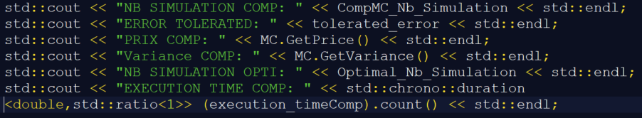

This will print the following kind of result:

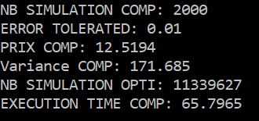

Note that the execution time is in seconds.

After this first run, the minimum number of simulations required is automatically stored so that one can directly run again the “simulate” method of the MC object. It will run with the optimal number of simulations. This corresponds to the following line:



## Construction of a Simulation for European Payoff with Variance Reduction techniques

One can either apply one of the following techniques or cumulate them together:

* Quasi random sequence
* Antithetic random variable
* Static Control Variate

We are going to show how to implement them individually.

### Quasi Random Sequence

1. Sobol Sequence

Two quasi random sequences are available: Van Der Corput and Sobol ones.

In order to use the Sobol Sequence, one has to change “Uniform Generator” line as follows:



Instead of:



And repeat the code shown previously.

Regarding the algorithm implementation, we started our work from (Press, Teukolsky, Vetterling, & Flannery, 2002).

1. Van Der Corput Sequence

To use this sequence and implement it with the Box Muller Algorithm, one must create two Van Der Corput sequences with two different bases that are prime numbers:

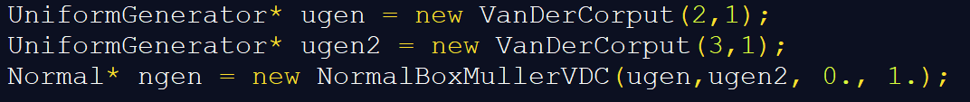

### Antithetic Random Variable

The antithetic technique is implemented for the generation of correlated gaussian vectors. To use it, two rows must be replaced compared to the reference code we gave.

First, for the random process, one must write:



Instead of:



Second, one must also write:



Instead of:



Otherwise, the reference stays the same.

### Static Control Variate

For this variance reduction technique, one should add a second payoff object for the control variate and compute its closed formula price before starting the Monte Carlo simulation.

First, one must add the 3 next lines to create the control variate and compute the closed formula price:

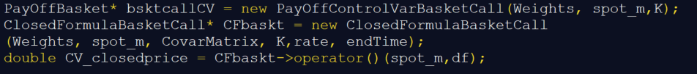

Second, the Monte Carlo object must be changed to:



Otherwise, the reference codes remain the same.

### Use Multiple Techniques

One can easily use two or three of the previous techniques together, keeping the same structure of code. However, to use at the same time Antithetic and Control Variate, one must write:



Note that the Random process is still the same as shown in the Antithetic part.

## Case where the Covariance Matrix is not invertible

To ensure that the generation of gaussian vectors is done properly, we coded two algorithms, one does the Cholesky decomposition into a lower triangular matrix, while the other uses the diagonalization process with eigenvalues and normalized eigenvectors. The latter can be used even when the covariance matrix is not invertible. The reference code must be modified as follows to compute its determined and then create the appropriate object:

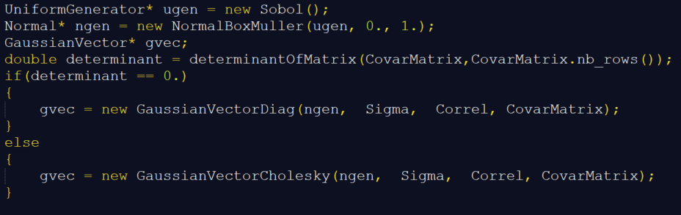

# Results for European Payoff

For all the following results, we show them with two different sets of inputs: Input 1 and Input 2.

**Input 1** is the following: we value a basket call option containing 3 assets:

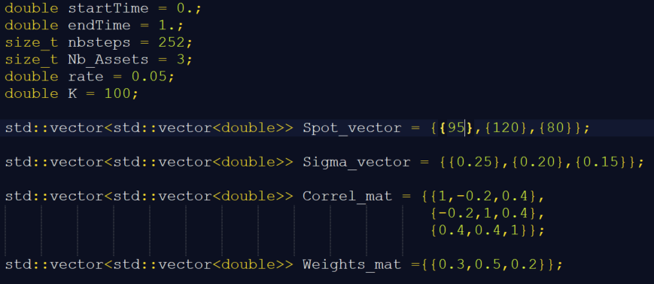

**Input 2** is the following: we value a basket call option containing 4 assets with a different covariance structure:

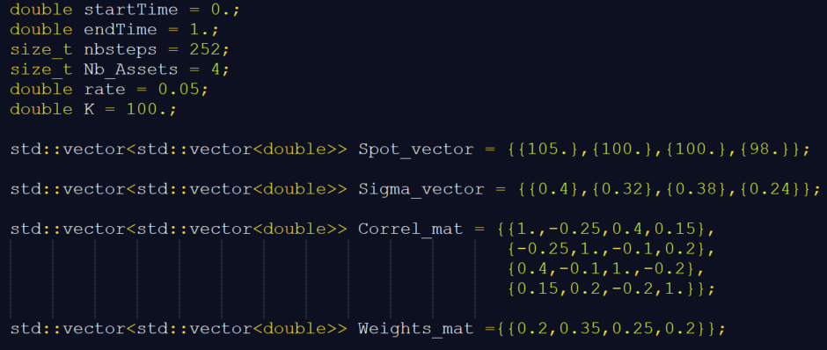

## No Variance Reduction

This is our benchmark simulation for the European basket call with the following inputs:

We obtain for Input 1 and 2:

|  |  |
| --- | --- |
| **Input 1** | **No Variance Reduction** |
| **Number of Simulations** | 2 000 |
| **Error Tolerated** | 0.01 |
| **Price** | 12.52 |
| **Variance** | 171.00 |
| **Required Number of Simulations** | 11 339 627 |
| **Execution Time (Seconds)** | 66 |

|  |  |  |
| --- | --- | --- |
| **Input 2** | **No Variance Reduction** | **No Variance Reduction** |
| **Number of Simulations** | 10 000 | 3000 |
| **Error Tolerated** | 0.01 | 0.01 |
| **Price** | 10.5 | 10.18 |
| **Variance** | 223.4 | 211.6 |
| **Required Number of Simulations** | 14 755 310 | 13 977 378 |
| **Execution Time (Seconds)** | 432 | 134 |

## Quasi-Random Sequence

1. **Sobol Sequence**

The good properties of the Sobol sequence are shown below, we compare it to the Ecuyer generator. On the next graphs, we can compare the first 50 points of each sequence:

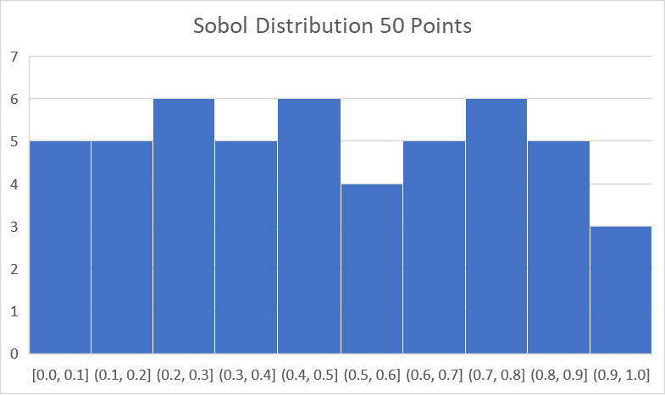

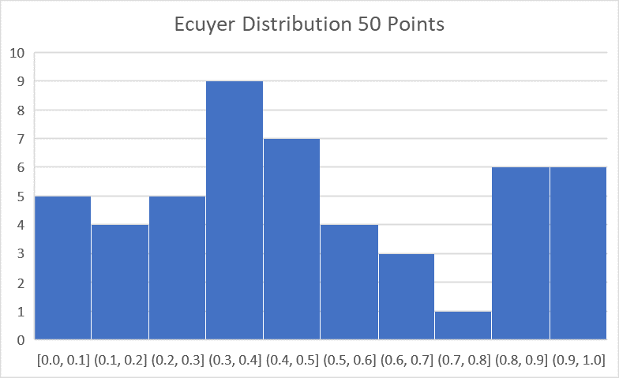

We observe that, even on small samples, the Sobol sequence replicates better the uniform distribution. Now, on a larger sample (2500), we obtain:

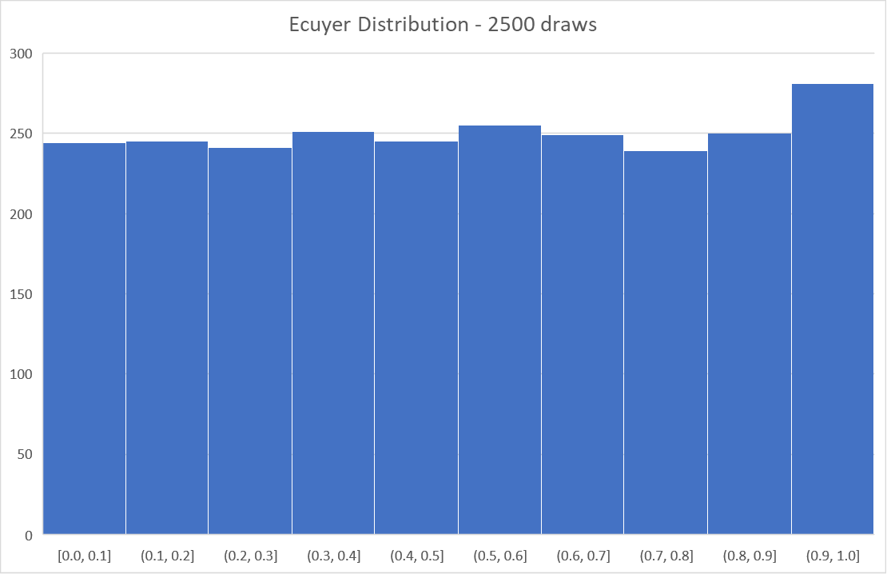

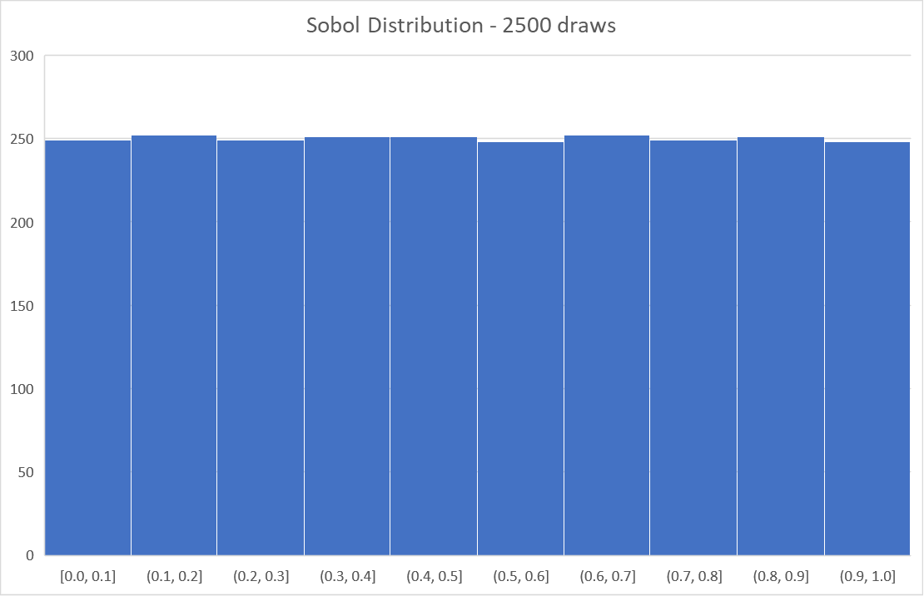

We can see that this property is also true for larger samples and that the Sobol sequence fits more a “true” uniform distribution.

|  |  |
| --- | --- |
| **Input 1** | **Sobol Sequence** |
| **Number of Simulations** | 2 000 |
| **Error Tolerated** | 0.01 |
| **Price** | 10.91 |
| **Variance** | 88.03 |
| **Required Number of Simulations** | 5 759 728 |
| **Execution Time (Seconds)** | 66 |

|  |  |  |
| --- | --- | --- |
| **Input 2** | **Sobol Sequence** | **Sobol Sequence** |
| **Number of Simulations** | 10 000 | 3000 |
| **Error Tolerated** | 0.01 | 0.01 |
| **Price** | 1.24 | 1.24 |
| **Variance** | 0.72 | 0.72 |
| **Required Number of Simulations** | 47 692 | 47 727 |
| **Execution Time (Seconds)** | 432 | 144 |

We can see that only applying the Sobol Sequence to generate Uniform distribution has a significant impact not only on the estimated variance, but also on the option price. For Input 1, we almost divide by two the number of simulations required to enter the confidence interval. Regarding Input 2, the results are even more important: we go from 14 million to 50 thousand. Interestingly, we also see that the price is very different from the one obtained we Ecuyer generator. We tried to increase to 10 000 the number of simulations to see if this result was just coming from the low number of simulations. It seems not. We conclude that the Sobol Sequence ability to replicate the Uniform distribution can improve the pricing. This improvement depends on the inputs and the product priced. We can divide the number of simulations by two, sometimes more, and sometimes maybe less.

## Antithetic Random Variable

On the next graphs, for a basket of 3 assets, we can see an example of a path generated for it and its corresponding antithetic path.

Zooming on asset 1, we can see that that the Antithetic path follows exactly the opposite path, and same thing for asset 2 and 3, which means the correlation between assets remains the same:

We obtain the following results:

|  |  |
| --- | --- |
| **Input 1** | **Antithetic** |
| **Number of Simulations** | 2 000 |
| **Error Tolerated** | 0.01 |
| **Price** | 12.42 |
| **Variance** | 20.45 |
| **Required Number of Simulations** | 1 350 579 |
| **Execution Time (Seconds)** | 42 |

|  |  |
| --- | --- |
| **Input 2** | **Antithetic** |
| **Number of Simulations** | 3000 |
| **Error Tolerated** | 0.01 |
| **Price** | 10.03 |
| **Variance** | 52.35 |
| **Required Number of Simulations** | 3 457 915 |
| **Execution Time (Seconds)** | 78 |

The Antithetic technique shows very good results regarding the variance of our simulations. For the variance and both inputs, it reduces by around 80% the number of simulations required. Another good aspect of using this technique is that it also reduces the algorithm speed. Indeed, we decrease the pricing speed by almost 40%.

We studied this technique to confirm we were going in the right direction while implementing it thanks to (Sigman, 2007).

## Static Control Variate

Using this technique led us to the following results:

|  |  |
| --- | --- |
| **Input 1** | **CV** |
| **Number of Simulations** | 2 000 |
| **Error Tolerated** | 0.01 |
| **Price** | 13.01 |
| **Variance** | 7.30 |
| **Required Number of Simulations** | 491 893 |
| **Execution Time (Seconds)** | 67 |

|  |  |
| --- | --- |
| **Input 2** | **CV** |
| **Number of Simulations** | 3 000 |
| **Error Tolerated** | 0.01 |
| **Price** | 12.07 |
| **Variance** | 19.85 |
| **Required Number of Simulations** | 1 311 301 |
| **Execution Time (Seconds)** | 145 |

From the above two tables, we can conclude that the use of this Control Variate for the basket call option enables a drastic variance reduction, which is even larger than the one allowed by the Antithetic technique. However, there is no improvement of the algorithm speed as it is the case with the Antithetic Random Variable. Now the estimated variance is reduced by more than 90% for both inputs.

## Quasi Monte Carlo and Antithetic Random Variable

Combining the two methods, we obtain:

|  |  |
| --- | --- |
| **Input 1** | **Sobol and Antithetic** |
| **Number of Simulations** | 2 000 |
| **Error Tolerated** | 0.01 |
| **Price** | 11.01 |
| **Variance** | 7.92 |
| **Required Number of Simulations** | 522 813 |
| **Execution Time (Seconds)** | 45 |

|  |  |
| --- | --- |
| **Input 2** | **Sobol and Antithetic** |
| **Number of Simulations** | 3 000 |
| **Error Tolerated** | 0.01 |
| **Price** | 1.23 |
| **Variance** | 0.015 |
| **Required Number of Simulations** | 988 |
| **Execution Time (Seconds)** | 53 |

For both inputs, combing Sobol Sequence and Antithetic Random Variable shows better result than using each technique individually. We now decrease the variance by more than 95%.

## Quasi Monte Carlo and Control Variate

Instead of Antithetic variable, we now combine Quasi Monte Carlo with the Control Variate and obtain:

|  |  |
| --- | --- |
| **Input 1** | **Sobol and CV** |
| **Number of Simulations** | 2 000 |
| **Error Tolerated** | 0.01 |
| **Price** | 13.71 |
| **Variance** | 10.57 |
| **Required Number of Simulations** | 698 081 |
| **Execution Time (Seconds)** | 67 |

|  |  |
| --- | --- |
| **Input 2** | **Sobol and CV** |
| **Number of Simulations** | 3 000 |
| **Error Tolerated** | 0.01 |
| **Price** | 9.48 |
| **Variance** | 0.004 |
| **Required Number of Simulations** | 276 |
| **Execution Time (Seconds)** | 142 |

The level of variance reduction for Input 2 is surprising. We know that it comes from using the Sobol Sequence. It remains unclear why the Sobol Sequence has such an impact on this second set of inputs.

## Control Variate and Antithetic Random Variable

|  |  |
| --- | --- |
| **Input 1** | **CV and Antithetic** |
| **Number of Simulations** | 2 000 |
| **Error Tolerated** | 0.01 |
| **Price** | 13.05 |
| **Variance** | 3.94 |
| **Required Number of Simulations** | 260 373 |
| **Execution Time (Seconds)** | 44 |

|  |  |
| --- | --- |
| **Input 2** | **CV and Antithetic** |
| **Number of Simulations** | 3 000 |
| **Error Tolerated** | 0.01 |
| **Price** | 12.03 |
| **Variance** | 8.74 |
| **Required Number of Simulations** | 577 166 |
| **Execution Time (Seconds)** | 79 |

Combined together, Control Variate and Antithetic Variable shows incredible results in terms of variance reduction, additionally to a faster algorithm. Again, the estimated variance is reduced by more than 95%.

## Using All Three Techniques

|  |  |
| --- | --- |
| **Input 1** | **3 Techniques** |
| **Number of Simulations** | 2 000 |
| **Error Tolerated** | 0.01 |
| **Price** | 13.66 |
| **Variance** | 4.4 |
| **Required Number of Simulations** | 290 634 |
| **Execution Time (Seconds)** | 43 |

|  |  |
| --- | --- |
| **Input 2** | **3 Techniques** |
| **Number of Simulations** | 2 000 |
| **Error Tolerated** | 0.01 |
| **Price** | 9.48 |
| **Variance** | 0.0017 |
| **Required Number of Simulations** | 112 |
| **Execution Time (Seconds)** | 53 |

Cumulating all three techniques allows for sure to significantly decrease the number of simulations required. For Input 1, extrapolating the time needed to run the same pricing simulation without any variance reduction technique would require around 104 hours to enter the confidence interval. Using all techniques decrease the computation time to less than 2 hours.

## Summary

**Input 1:**

|  |  |  |  |  |
| --- | --- | --- | --- | --- |
|  | **No Variance Reduction** | **Sobol** | **Antithetic** | **Control Variate** |
| **Number of Simulations** | 2 000 | 2 000 | 2000 | 2000 |
| **Error Tolerated** | 0.01 | 0.01 | 0.01 | 0.01 |
| **Price** | 12.52 | 10.91 | 12.42 | 13 |
| **Variance** | 171.00 | 88.03 | 20.45 | 7.296 |
| **Required Number of Simulations** | 11 339 627 | 5 759 728 | 1 350 579 | 481 893 |

|  |  |  |  |  |
| --- | --- | --- | --- | --- |
|  | **Sobol and Antithetic** | **Sobol and CV** | **CV and Anti** | **3 Techniques** |
| **Number of Simulations** | 2000 | 2000 | 2000 | 2000 |
| **Error Tolerated** | 0.01 | 0.01 | 0.01 | 0.01 |
| **Price** | 11.01 | 13.71 | 13.05 | 13.66 |
| **Variance** | 7.92 | 10.5691 | 3.94 | 4.4 |
| **Required Number of Simulations** | 522 813 | 698 081 | 260 373 | 290 634 |
| **Execution Time (Seconds)** | 45 | 67 | 44 | 43 |

**Input 2:**

|  |  |  |  |  |
| --- | --- | --- | --- | --- |
|  | **No Variance Reduction** | **Sobol** | **Antithetic** | **Control Variate** |
| **Number of Simulations** | 3 000 | 3 000 | 3 000 | 3 000 |
| **Error Tolerated** | 0.01 | 0.01 | 0.01 | 0.01 |
| **Price** | 10.18 | 1.24 | 10.03 | 12.07 |
| **Variance** | 211.62 | 0.72 | 52.35 | 19.85 |
| **Required Number of Simulations** | 13 977 378 | 47 727 | 3 457 915 | 1 311 301 |
| **Execution Time (Seconds)** | 134 | 144 | 78 | 83 |

|  |  |  |  |  |
| --- | --- | --- | --- | --- |
|  | **Sobol and Antithetic** | **Sobol and CV** | **CV and Anti** | **3 Techniques** |
| **Number of Simulations** | 3 000 | 3 000 | 3 000 | 3 000 |
| **Error Tolerated** | 0.01 | 0.01 | 0.01 | 0.01 |
| **Price** | 1.23 | 9.48 | 12.0283 | 9.48 |
| **Variance** | 0.015 | 0.004 | 8.74 | 0.0017 |
| **Required Number of Simulations** | 988 | 276 | 577 166 | 112 |
| **Execution Time (Seconds)** | 53 | 85 | 79 | 53 |

# American and Bermudan Options

## Construction of a Simulation for path dependant Payoff with Variance Reduction techniques

Creating a MonteCarlo simulation for path dependant options (American Basket options and Bermudan basket options) may require additional parameters with respect to the European one. First, presenting quickly methodology will give insights on these additional parameters and then the possible features of the product will be taken into account.

## The Longstaff-Schwartz approach

The following approach is based on the paper of Longstaff and Schwartz (Longstaff and Schwartz, 2001) who proposed a framework based on a general Least Square regression to estimate the continuation value of these products allowing to build Monte Carlo algorithms in order to price these products. In a nutshell, one look for the continuation value at each time step that is simply the conditional expectation of the payoff at one step ahead knowing the value taken by the underlying at the previous time step.

$$Continuation Value= E\left(Y | X\right)$$

The proposition of *LS* is to approach the above quantity using GLS (General Least Square) method that boils down to estimate the following regression:

$$e^{-rdt}Y=\sum_{m=1}^{M}{β_{t}^{j}*F(X)}$$

Where F is a set of functions (j functions) applied to the vector of the underlying spot value X.

After finding the Betas through the regression, of will compare this quantity with the immediate payoff and take the max between the two at each time step and for each in-the-money paths in order to update the value at each step. Finally, the monteCarlo price will be given by:

$\frac{1}{M}\sum_{m=1}^{M}{e^{-r*t_{m}^{*}} Y_{m}}$

Where the final discounting will take into account the optimal stopping time (optimal time to be exercised) for each path.

The brief presentation of the method shows the need for the first additional parameter that is a vector of pointers to basis function (F) that will allow to estimate the continuation value. In generality, one should check that the continuation value for a specified payoff belongs to a $L^{n}$ space and because of that space will be a Hilbert one, the continuation value could be approximated as a linear combination of any elements of that space (these functions can be found in the Basis Functions class) and the parameter **polynomial** in the MonteCarlo constructor. As per the reference paper, simple polynomes are implemented (*ie $X^{n} ∀n an integer)$* as well as Laguerre polynomes and Hermite polynomes.

The polynomes functions will be constructed with the following manner:

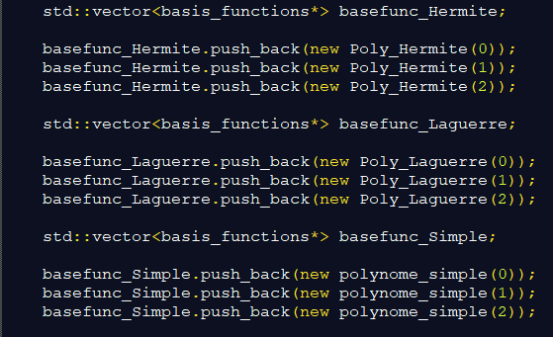

## Path dependant exercice

As the Bermudan option can be exercised at a set of contractual predetermined dates, one need to take this feature into account. This will be done through two parameters.

Starting the pointer to a generic class of **CalendarManagement** functions that will allow to assemble the right underlying asset value sequence extracted from the stock path generated. This can be either an interpolation function, or a function that manages dates and calendar object to fit the term sheet. In all our simulations we worked with the **rounded_workingdays** class. This object takes only an int parameter that will set the number of following working days one need to take when searching for the reference spot. Taking the example of a Bermudan swaption that could be exercised each 28th of the month. If the 28th is a non-worked day than the parameter of the class constructor allow to take the following worked day (or two following worked day etc…) looking like this:



The second parameter inside the Bermudan MonteCarlo constructor will be a vector representing the different dates at which one can exercised the product. In the following simulations, the vector will contain doubles that are each time a fraction of the total life of the trade (in days) each fraction representing a possible date of exercise. Creation can be done in the following manner:

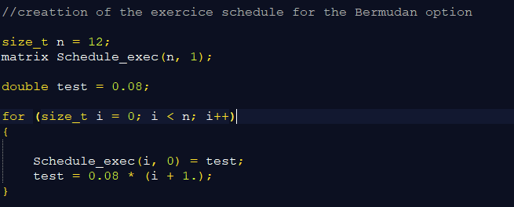

For the implementation of the algorithm, we took as a reference the paper of (Gustafsson, 2015).

# Results for American and Bermudan Payoff

One kept the same input parameters as the European case. The additional parameters will be as follow:

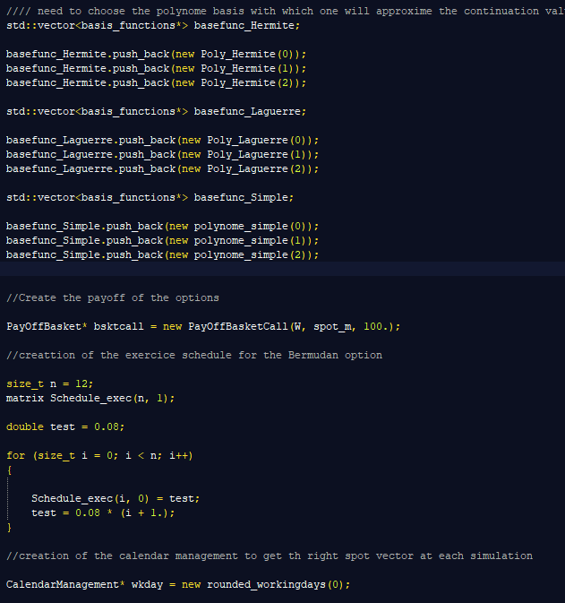

In the following subsections, each time one will present results comparing the three different sets of polynomes (with orders 0, 1 and 2) to gauge a possible effect when choosing the basis. All simulations presented are based on a 2000 sample. Even if our primary goal is to price Bermudan options, pricing the American equivalent is also a good practice to check for consistency in the pricing. Indeed, as the optionality the price of the American should always be higher will the European one should be cheaper than the Bermudan. Having these boundaries in mind, one can proceed to the analysis of the following results.

## No variance reduction

|  |  |  |  |
| --- | --- | --- | --- |
| **Input 1 – Bermudan case** | **Laguerre** | **Hermite** | **Simples** |
| **Number of Simulations** | 2 000 | 2000 | 2000 |
| **Error Tolerated** | 0.01 | 0.01 | 0.01 |
| **Price** | 10.7975 | 10.7975 | 10.7975 |
| **Variance** | 128.81 | 128.81 | 128.81 |
| **Required Number of Simulations** | 8 507 767 | 8 507 767 | 8 507 767 |
| **Execution Time (Seconds)** | 29.89 | 24.82 | 26.41 |

|  |  |  |  |
| --- | --- | --- | --- |
| **Input 2 – Bermudan case** | **Laguerre** | **Hermite** | **Simples** |
| **Number of Simulations** | 2 000 | 2000 | 2000 |
| **Error Tolerated** | 0.01 | 0.01 | 0.01 |
| **Price** | 9.23838 | 9.23838 | 9.23838 |
| **Variance** | 159.22 | 159.22 | 159.22 |
| **Required Number of Simulations** | 10 536 242 | 10 536 242 | 10 536 242 |
| **Execution Time (Seconds)** | 31.58 | 30.67 | 32.13 |

The pricing seems good as the American is more expensive than the European option price previously (11.34 vs 8.87) while the European is cheaper than the European one. However both show high variance and the number of simulations is quite low compared to the one needed to enter the confidence interval. Which seems to stay consistent in the second sample.

|  |  |  |  |
| --- | --- | --- | --- |
| **Input 1 – American case** | **Laguerre** | **Hermite** | **Simples** |
| **Number of Simulations** | 2 000 | 2000 | 2000 |
| **Error Tolerated** | 0.01 | 0.01 | 0.01 |
| **Price** | 11.3403 | 11.3403 | 11.3403 |
| **Variance** | 114.714 | 114.714 | 114.714 |
| **Required Number of Simulations** | 9 558 184 | 9 558 184 | 9 558 184 |
| **Execution Time (Seconds)** | 45.91 | 45.29 | 44.8 |

|  |  |  |  |
| --- | --- | --- | --- |
| **Input 2 – American case** | **Laguerre** | **Hermite** | **Simples** |
| **Number of Simulations** | 2 000 | 2000 | 2000 |
| **Error Tolerated** | 0.01 | 0.01 | 0.01 |
| **Price** | 9.94461 | 9.94461 | 9.94461 |
| **Variance** | 186.066 | 186.066 | 186.066 |
| **Required Number of Simulations** | 12 289 462 | 12 289 462 | 12 289 462 |
| **Execution Time (Seconds)** | 41.69 | 40.63 | 41.2969 |

It is on the other hand reassuring to see that the American case (Bermudan when the number of possible exercices tend to infinite) is more expensive than the Bermudan. However, the accuracy of the algorithm is still quite low and it requires a high number of simulations to enter the confidence interval. Finally, the choice of each the function family seems to have no impact on the price itself (which is expected as these are all elements from L2 and therefore all good candidates to approach the continuation value) but it could be worth to choose the one that minimizes the time of computation for a given level of accuracy.

## Quasi Random Sequence

In this subsection, one will use Van der Corput and Sobol sequences to generate uniform numbers in order to build the Brownian motion underlying the Black and Scholes diffusion. Implemented this approach aims at reducing the discrepancy of the simulated numbers resulting in reducing the variance among the simulations.

### Van der Corput

|  |  |  |  |
| --- | --- | --- | --- |
| **Input 1 – Bermudan case** | **Laguerre** | **Hermite** | **Simples** |
| **Number of Simulations** | 2 000 | 2000 | 2000 |
| **Error Tolerated** | 0.01 | 0.01 | 0.01 |
| **Price** | 6.97936 | 6.97936 | 6.97936 |
| **Variance** | 10.409 | 10.409 | 10.409 |
| **Required Number of Simulations** | 687 501 | 687 501 | 687 501 |
| **Execution Time (Seconds)** | 25.68 | 26.37 | 26. |

|  |  |  |  |
| --- | --- | --- | --- |
| **Input 2 – Bermudan case** | **Laguerre** | **Hermite** | **Simples** |
| **Number of Simulations** | 2 000 | 2000 | 2000 |
| **Error Tolerated** | 0.01 | 0.01 | 0.01 |
| **Price** | 0.978428 | 0.978428 | 0.978428 |
| **Variance** | 1.32632 | 1.32632 | 1.32632 |
| **Required Number of Simulations** | 87 602 | 87 602 | 87 602 |
| **Execution Time (Seconds)** | 38.86 | 32.55 | 32.11 |

|  |  |  |  |
| --- | --- | --- | --- |
| **Input 1 – American case** | **Laguerre** | **Hermite** | **Simples** |
| **Number of Simulations** | 2 000 | 2000 | 2000 |
| **Error Tolerated** | 0.01 | 0.01 | 0.01 |
| **Price** | 7.13465 | 7.13465 | 7.13465 |
| **Variance** | 6.07449 | 6.07449 | 6.07449 |
| **Required Number of Simulations** | 401 214 | 401 214 | 401 214 |
| **Execution Time (Seconds)** | 49.44 | 51.29 | 49.52 |

|  |  |  |  |
| --- | --- | --- | --- |
| **Input 2 – American case** | **Laguerre** | **Hermite** | **Simples** |
| **Number of Simulations** | 2 000 | 2000 | 2000 |
| **Error Tolerated** | 0.01 | 0.01 | 0.01 |
| **Price** | 1.04159 | 1.04159 | 1.04159 |
| **Variance** | 1.37274 | 1.37274 | 1.37274 |
| **Required Number of Simulations** | 90 667 | 90 667 | 90 667 |
| **Execution Time (Seconds)** | 43.6165 | 41.85 | 47.1037 |

If we can see a large reduction in variance and in the number of optimal simulations, it is quite strange to see that prices boundaries are violated. In that case this can be linked to the choice of the basis in the Van Der Corput generation that seems to affect largely the performance of the algorithm.

### Sobol

|  |  |  |  |
| --- | --- | --- | --- |
| **Input 1 – Bermudan case** | **Laguerre** | **Hermite** | **Simples** |
| **Number of Simulations** | 2 000 | 2000 | 2000 |
| **Error Tolerated** | 0.01 | 0.01 | 0.01 |
| **Price** | 8.81811 | 8.81811 | 8.81811 |
| **Variance** | 62.1244 | 62.1244 | 62.1244 |
| **Required Number of Simulations** | 4 103 256 | 4 103 256 | 4 103 256 |
| **Execution Time (Seconds)** | 24.81 | 27.09 | 27.39 |

|  |  |  |  |
| --- | --- | --- | --- |
| **Input 2 – Bermudan case** | **Laguerre** | **Hermite** | **Simples** |
| **Number of Simulations** | 2 000 | 2000 | 2000 |
| **Error Tolerated** | 0.01 | 0.01 | 0.01 |
| **Price** | 0.835996 | 0.835996 | 0.835996 |
| **Variance** | 0.633332 | 0.633332 | 0.633332 |
| **Required Number of Simulations** | 41 830 | 41 830 | 41 830 |
| **Execution Time (Seconds)** | 31.1 | 32.13 | 30.94 |

|  |  |  |  |
| --- | --- | --- | --- |
| **Input 1 – American case** | **Laguerre** | **Hermite** | **Simples** |
| **Number of Simulations** | 2 000 | 2000 | 2000 |
| **Error Tolerated** | 0.01 | 0.01 | 0.01 |
| **Price** | 9.43546 | 9.43546 | 9.43546 |
| **Variance** | 72.6542 | 72.6542 | 72.6542 |
| **Required Number of Simulations** | 4 798 737 | 4 798 737 | 4 798 737 |
| **Execution Time (Seconds)** | 49.48 | 47.43 | 46.01 |

|  |  |  |  |
| --- | --- | --- | --- |
| **Input 2 – American case** | **Laguerre** | **Hermite** | **Simples** |
| **Number of Simulations** | 2 000 | 2000 | 2000 |
| **Error Tolerated** | 0.01 | 0.01 | 0.01 |
| **Price** | 1.071 | 1.071 | 1.071 |
| **Variance** | 0.712879 | 0.712879 | 0.712879 |
| **Required Number of Simulations** | 47 084 | 47 084 | 47 084 |
| **Execution Time (Seconds)** | 43.17 | 43.8 | 45.24 |

In the Sobol case we encounter the same issue that in the above subjection with Van Der Corput, that prices are quite far from what should be the true price. In addition, it seems that the Van der Corput sequence seems to yield better results in terms of variance reductions and optimal simulations.

## Quasi Monte Carlo and Antithetic Random Variable

### Van der Corput

|  |  |  |  |
| --- | --- | --- | --- |
| **Input 1 – Bermudan case** | **Laguerre** | **Hermite** | **Simples** |
| **Number of Simulations** | 2 000 | 2000 | 2000 |
| **Error Tolerated** | 0.01 | 0.01 | 0.01 |
| **Price** | 6.97631 | 6.97631 | 6.97631 |
| **Variance** | 0.0401633 | 0.0401633 | 0.0401633 |
| **Required Number of Simulations** | 2652 | 2652 | 2652 |
| **Execution Time (Seconds)** | 16.70 | 18.55 | 18.46 |

|  |  |  |  |
| --- | --- | --- | --- |
| **Input 2 – Bermudan case** | **Laguerre** | **Hermite** | **Simples** |
| **Number of Simulations** | 2 000 | 2000 | 2000 |
| **Error Tolerated** | 0.01 | 0.01 | 0.01 |
| **Price** | 0.980551 | 0.980551 | 0.980551 |
| **Variance** | 0.196778 | 0.196778 | 0.196778 |
| **Required Number of Simulations** | 12 996 | 12 996 | 12 996 |
| **Execution Time (Seconds)** | 18.76 | 19.67 | 20.26 |

|  |  |  |  |
| --- | --- | --- | --- |
| **Input 1 – American case** | **Laguerre** | **Hermite** | **Simples** |
| **Number of Simulations** | 2 000 | 2000 | 2000 |
| **Error Tolerated** | 0.01 | 0.01 | 0.01 |
| **Price** | 7.13456 | 7.13456 | 7.13456 |
| **Variance** | 0.0160825 | 0.0160825 | 0.0160825 |
| **Required Number of Simulations** | 1062 | 1062 | 1062 |
| **Execution Time (Seconds)** | 39.47 | 46.44 | 47 |

|  |  |  |  |
| --- | --- | --- | --- |
| **Input 2 – American case** | **Laguerre** | **Hermite** | **Simples** |
| **Number of Simulations** | 2 000 | 2000 | 2000 |
| **Error Tolerated** | 0.01 | 0.01 | 0.01 |
| **Price** | 1.01147 | 1.01147 | 1.01147 |
| **Variance** | 0.201214 | 0.201214 | 0.201214 |
| **Required Number of Simulations** | 13 289 | 13 289 | 13 289 |
| **Execution Time (Seconds)** | 31.78 | 31.61 | 32.69 |

### Sobol

|  |  |  |  |
| --- | --- | --- | --- |
| **Input 1 – Bermudan case** | **Laguerre** | **Hermite** | **Simples** |
| **Number of Simulations** | 2 000 | 2000 | 2000 |
| **Error Tolerated** | 0.01 | 0.01 | 0.01 |
| **Price** | 9.14256 | 9.14256 | 9.14256 |
| **Variance** | 6.78828 | 6.78828 | 6.78828 |
| **Required Number of Simulations** | 448 359 | 448 359 | 448 359 |
| **Execution Time (Seconds)** | 16.83 | 18.5 | 26.12 |

|  |  |  |  |
| --- | --- | --- | --- |
| **Input 2 – Bermudan case** | **Laguerre** | **Hermite** | **Simples** |
| **Number of Simulations** | 2 000 | 2000 | 2000 |
| **Error Tolerated** | 0.01 | 0.01 | 0.01 |
| **Price** | 1.21804 | 1.21804 | 1.21804 |
| **Variance** | 0.0283748 | 0.0283748 | 0.0283748 |
| **Required Number of Simulations** | 1874 | 1874 | 1874 |
| **Execution Time (Seconds)** | 19.28 | 20.45 | 20.05 |

|  |  |  |  |
| --- | --- | --- | --- |
| **Input 1 – American case** | **Laguerre** | **Hermite** | **Simples** |
| **Number of Simulations** | 2 000 | 2000 | 2000 |
| **Error Tolerated** | 0.01 | 0.01 | 0.01 |
| **Price** | 9.86449 | 9.86449 | 9.86449 |
| **Variance** | 8.44818 | 8.44818 | 8.44818 |
| **Required Number of Simulations** | 557 993 | 557 993 | 557 993 |
| **Execution Time (Seconds)** | 37.37 | 40.31 | 43 |

|  |  |  |  |
| --- | --- | --- | --- |
| **Input 2 – American case** | **Laguerre** | **Hermite** | **Simples** |
| **Number of Simulations** | 2 000 | 2000 | 2000 |
| **Error Tolerated** | 0.01 | 0.01 | 0.01 |
| **Price** | 1.27057 | 1.27057 | 1.27057 |
| **Variance** | 0.0308042 | 0.0308042 | 0.0308042 |
| **Required Number of Simulations** | 2034 | 2034 | 2034 |
| **Execution Time (Seconds)** | 36.36 | 35.11 | 35.67 |

Adding the Antithetic variable does enhance the variance reduction and the number of optimal simulations needed. However, one can see that the pricing on the second set of parameters is still inconsistent.

## Quasi Monte Carlo and Static Control Variate

### Van der Corput

|  |  |  |  |
| --- | --- | --- | --- |
| **Input 1 – Bermudan case** | **Laguerre** | **Hermite** | **Simples** |
| **Number of Simulations** | 2 000 | 2000 | 2000 |
| **Error Tolerated** | 0.01 | 0.01 | 0.01 |
| **Price** | 11.7092 | 11.7092 | 11.7092 |
| **Variance** | 0.552085 | 0.552085 | 0.552085 |
| **Required Number of Simulations** | 36 464 | 36 464 | 36 464 |
| **Execution Time (Seconds)** | 28.26 | 29.47 | 26.08 |

|  |  |  |  |
| --- | --- | --- | --- |
| **Input 2 – Bermudan case** | **Laguerre** | **Hermite** | **Simples** |
| **Number of Simulations** | 2 000 | 2000 | 2000 |
| **Error Tolerated** | 0.01 | 0.01 | 0.01 |
| **Price** | 9.94713 | 9.87037 | 10.0616 |
| **Variance** | 0.0104723 | 1.60847 | 1.14419 |
| **Required Number of Simulations** | 691 | 106 237 | 75 572 |
| **Execution Time (Seconds)** | 31.8864 | 33.29 | 33.31 |

|  |  |  |  |
| --- | --- | --- | --- |
| **Input 1 – American case** | **Laguerre** | **Hermite** | **Simples** |
| **Number of Simulations** | 2 000 | 2000 | 2000 |
| **Error Tolerated** | 0.01 | 0.01 | 0.01 |
| **Price** | 11.6002 | 14.1668 | 14.1668 |
| **Variance** | 0.261268 | 5.56391 | 5.56391 |
| **Required Number of Simulations** | 17 256 | 367 490 | 367 490 |
| **Execution Time (Seconds)** | 73.54 | 75.1 | 73.73 |

|  |  |  |  |
| --- | --- | --- | --- |
| **Input 2 – American case** | **Laguerre** | **Hermite** | **Simples** |
| **Number of Simulations** | 2 000 | 2000 | 2000 |
| **Error Tolerated** | 0.01 | 0.01 | 0.01 |
| **Price** | 10.1255 | 9.44823 | 9.55913 |
| **Variance** | 1.95975 | 1.15183 | 1.91568 |
| **Required Number of Simulations** | 129 439 | 76 076 | 126 528 |
| **Execution Time (Seconds)** | 68.11 | 58.06 | 57.13 |

Interestingly, the first test does show a lack of consistency as the Bermudan is more expensive than the American counterpart while the condition is respected in the second one. Nonetheless, one can see from table above that the pricing on the second set of parameters is well closer to the reality than in the previous case (antithetic and quasi random generation).

### Sobol

|  |  |  |  |
| --- | --- | --- | --- |
| **Input 1 – Bermudan case** | **Laguerre** | **Hermite** | **Simples** |
| **Number of Simulations** | 2 000 | 2000 | 2000 |
| **Error Tolerated** | 0.01 | 0.01 | 0.01 |
| **Price** | 12.8095 | 12.8095 | 12.8095 |
| **Variance** | 8.30296 | 8.30296 | 8.30296 |
| **Required Number of Simulations** | 548 402 | 548 402 | 548 402 |
| **Execution Time (Seconds)** | 27.32 | 27.44 | 27.21 |

|  |  |  |  |
| --- | --- | --- | --- |
| **Input 2 – Bermudan case** | **Laguerre** | **Hermite** | **Simples** |
| **Number of Simulations** | 2 000 | 2000 | 2000 |
| **Error Tolerated** | 0.01 | 0.01 | 0.01 |
| **Price** | 9.96012 | 9.72048 | 9.5904 |
| **Variance** | 0.00875142 | 0.58483 | 0.5604 |
| **Required Number of Simulations** | 578 | 38 627 | 37 148 |
| **Execution Time (Seconds)** | 31.99 | 32.88 | 32.33 |

|  |  |  |  |
| --- | --- | --- | --- |
| **Input 1 – American case** | **Laguerre** | **Hermite** | **Simples** |
| **Number of Simulations** | 2 000 | 2000 | 2000 |
| **Error Tolerated** | 0.01 | 0.01 | 0.01 |
| **Price** | 13.2108 | 16.5827 | 13.2108 |
| **Variance** | 12.6466 | 72.2583 | 12.6466 |
| **Required Number of Simulations** | 835 295 | 4 772 588 | 835 295 |
| **Execution Time (Seconds)** | 66.05 | 66.05 | 65.4 |

|  |  |  |  |
| --- | --- | --- | --- |
| **Input 2 – American case** | **Laguerre** | **Hermite** | **Simples** |
| **Number of Simulations** | 2 000 | 2000 | 2000 |
| **Error Tolerated** | 0.01 | 0.01 | 0.01 |
| **Price** | 10.248 | 10.2175 | 10.1326 |
| **Variance** | 0.477764 | 0.505947 | 0.562468 |
| **Required Number of Simulations** | 31 555 | 33 417 | 37 150 |
| **Execution Time (Seconds)** | 60.85 | 60.63 | 61.2 |

From the Van der Corput shown above, one can see that the pricing boundaries are no more violated here giving therefore results that are more consistent with our expectations.

## Antithetic Random Variable

The aim of the Antithetic Random Variable is to lower the variance of the simulated price by splitting the subset into two sub samples in order to simulated our target variable (Y) as the mean between X1 and X2, where both are negatively correlated. This should result in a lower variance of the simulated price in addition to lower time of computation and a lower optimal number of simulations to enter our confidence interval.

|  |  |  |  |
| --- | --- | --- | --- |
| **Input 1 – Bermudan case** | **Laguerre** | **Hermite** | **Simples** |
| **Number of Simulations** | 2 000 | 2000 | 2000 |
| **Error Tolerated** | 0.01 | 0.01 | 0.01 |
| **Price** | 10.6055 | 10.6055 | 10.6055 |
| **Variance** | 16.6115 | 16.6115 | 16.6115 |
| **Required Number of Simulations** | 1 097 171 | 1 097 171 | 1 097 171 |
| **Execution Time (Seconds)** | 16.64 | 19.15 | 18.44 |

|  |  |  |  |
| --- | --- | --- | --- |
| **Input 2 – Bermudan case** | **Laguerre** | **Hermite** | **Simples** |
| **Number of Simulations** | 2 000 | 2000 | 2000 |
| **Error Tolerated** | 0.01 | 0.01 | 0.01 |
| **Price** | 9.37993 | 9.37993 | 9.37993 |
| **Variance** | 39.3047 | 39.3047 | 39.3047 |
| **Required Number of Simulations** | 2 596 037 | 2 596 037 | 2 596 037 |
| **Execution Time (Seconds)** | 19.08 | 19.43 | 19.82 |

|  |  |  |  |
| --- | --- | --- | --- |
| **Input 1 – American case** | **Laguerre** | **Hermite** | **Simples** |
| **Number of Simulations** | 2 000 | 2000 | 2000 |
| **Error Tolerated** | 0.01 | 0.01 | 0.01 |
| **Price** | 11.2381 | 11.2381 | 11.2381 |
| **Variance** | 19.8566 | 19.8566 | 19.8566 |
| **Required Number of Simulations** | 1 311 507 | 1 311 507 | 1 311 507 |
| **Execution Time (Seconds)** | 35.2 | 62.69 | 40.64 |

|  |  |  |  |
| --- | --- | --- | --- |
| **Input 2 – American case** | **Laguerre** | **Hermite** | **Simples** |
| **Number of Simulations** | 2 000 | 2000 | 2000 |
| **Error Tolerated** | 0.01 | 0.01 | 0.01 |
| **Price** | 10.0334 | 10.0334 | 10.0334 |
| **Variance** | 46.75 | 46.75 | 46.75 |
| **Required Number of Simulations** | 3 087 790 | 3 087 790 | 3 087 790 |
| **Execution Time (Seconds)** | 32.57 | 31.61 | 31.31 |

If the quasi random generation did not yield good results with the antithetic method, this is not the case when using traditional random generation through the Ecuyer Combined generator. Indeed, in the four table above, relationship is respected between the Bermudan and the American options. In addition, the gain in computation time is large which has to be seen in pair with the large reduction in variance (from the vanilla case displayed at the beginning of this section) in addition to the large decrease in optimal simulations needed.

## Static Control Variate

This approach aims at using the possible existence of a payoff that has the same mean as our initial payoff but at a lower price and as nearly the same cost of simulation. Simulating both at the same take and adjusting by the close form price of the control payoff should compensate some way for the downward looking bias inherent to the MonteCarlo approach. In the same spirit as before, this should result This should result in a lower variance of the simulated price in addition to a lower optimal number of simulations to enter our confidence interval. However, the computation time could be higher as one simulates two payoffs at the same time (multiplying by almost two the computations made).

|  |  |  |  |
| --- | --- | --- | --- |
| **Input 1 – Bermudan case** | **Laguerre** | **Hermite** | **Simples** |
| **Number of Simulations** | 2 000 | 2000 | 2000 |
| **Error Tolerated** | 0.01 | 0.01 | 0.01 |
| **Price** | 12.2127 | 12.2127 | 12.2127 |
| **Variance** | 6.58268 | 6.58268 | 6.58268 |
| **Required Number of Simulations** | 434 779 | 434 779 | 434 779 |
| **Execution Time (Seconds)** | 28.18 | 26.65 | 27.46s |

|  |  |  |  |
| --- | --- | --- | --- |
| **Input 2 – Bermudan case** | **Laguerre** | **Hermite** | **Simples** |
| **Number of Simulations** | 2 000 | 2000 | 2000 |
| **Error Tolerated** | 0.01 | 0.01 | 0.01 |
| **Price** | 12.2048 | 12.2048 | 12.2048 |
| **Variance** | 14.5196 | 14.5196 | 14.5196 |
| **Required Number of Simulations** | 959 007 | 959 007 | 959 007 |
| **Execution Time (Seconds)** | 32.18 | 31.9 | 32.29 |

|  |  |  |  |
| --- | --- | --- | --- |
| **Input 1 – American case** | **Laguerre** | **Hermite** | **Simples** |
| **Number of Simulations** | 2 000 | 2000 | 2000 |
| **Error Tolerated** | 0.01 | 0.01 | 0.01 |
| **Price** | 12.3211 | 12.3211 | 12.4089 |
| **Variance** | 7.44122 | 7.44122 | 10.2849 |
| **Required Number of Simulations** | 491 485 | 491 485 | 679 307 |
| **Execution Time (Seconds)** | 64.6 | 62.78 | 63.77 |

|  |  |  |  |
| --- | --- | --- | --- |
| **Input 2 – American case** | **Laguerre** | **Hermite** | **Simples** |
| **Number of Simulations** | 2 000 | 2000 | 2000 |
| **Error Tolerated** | 0.01 | 0.01 | 0.01 |
| **Price** | 12.5272 | 12.5272 | 12.5272 |
| **Variance** | 17.9082 | 17.9082 | 17.9082 |
| **Required Number of Simulations** | 1 182 817 | 1 182 817 | 1 182 817 |
| **Execution Time (Seconds)** | 55.84 | 56.2 | 54.78 |

Same conclusion can be inferred here than in the previous subsection (antithetic) with a large reduction in variance and optimal simulations needed. However, this method is more intensive in computation as there are no split in the simulation but there is twice as much as calculus needed.

## Static Control Variate and Antithetic Control Variable

One can see that the two previous techniques proved to reduce the variance as well as the number of optimal simulations. The following results present the combination of both approach *ie* pricing both the option and its static control counterpart on the initial set of simulation and its antithetic counterpart. There is not so much hope for reduction in computation time however the aim will be still reducing the variance and the optimal number of simulations needed.

|  |  |  |  |
| --- | --- | --- | --- |
| **Input 1 – Bermudan case** | **Laguerre** | **Hermite** | **Simples** |
| **Number of Simulations** | 2 000 | 2000 | 2000 |
| **Error Tolerated** | 0.01 | 0.01 | 0.01 |
| **Price** | 9.62734 | 9.62734 | 9.62734 |
| **Variance** | 27.3046 | 27.3046 | 27.3046 |
| **Required Number of Simulations** | 1 803 442 | 1 803 442 | 1 803 442 |
| **Execution Time (Seconds)** | 17.9 | 16.47 | 15.79 |

|  |  |  |  |
| --- | --- | --- | --- |
| **Input 2 – Bermudan case** | **Laguerre** | **Hermite** | **Simples** |
| **Number of Simulations** | 2 000 | 2000 | 2000 |
| **Error Tolerated** | 0.01 | 0.01 | 0.01 |
| **Price** | 9.33723 | 9.33723 | 9.33723 |
| **Variance** | 36.0617 | 36.0617 | 36.0617 |
| **Required Number of Simulations** | 2 381 836 | 2 381 836 | 2 381 836 |
| **Execution Time (Seconds)** | 20.95 | 20.44 | 20.20 |

|  |  |  |  |
| --- | --- | --- | --- |
| **Input 1 – American case** | **Laguerre** | **Hermite** | **Simples** |
| **Number of Simulations** | 2 000 | 2000 | 2000 |
| **Error Tolerated** | 0.01 | 0.01 | 0.01 |
| **Price** | 12.39 | 16.1072 | 15.447 |
| **Variance** | 3.72902 | 28.3134 | 32.4408 |
| **Required Number of Simulations** | 246 298 | 1 870 073 | 2 142 681 |
| **Execution Time (Seconds)** | 61.9 | 61.39 | 60.75 |

|  |  |  |  |
| --- | --- | --- | --- |
| **Input 2 – American case** | **Laguerre** | **Hermite** | **Simples** |
| **Number of Simulations** | 2 000 | 2000 | 2000 |
| **Error Tolerated** | 0.01 | 0.01 | 0.01 |
| **Price** | 12.4697 | 14.2727 | 12.8953 |
| **Variance** | 8.07072 | 29.5586 | 13.3781 |
| **Required Number of Simulations** | 533 062 | 1 952 314 | 883 611 |
| **Execution Time (Seconds)** | 46.83 | 45.80 | 47.45 |

## Using all three techniques

Now that we have seen quite an improvement taking either quasi random numbers or variance reduction techniques, one can build the algorithm using quasi random numbers generation in addition to both Static control and antithetic variable methods at the same time.

### Van Der Corput

|  |  |  |  |
| --- | --- | --- | --- |
| **Input 1 – Bermudan case** | **Laguerre** | **Hermite** | **Simples** |
| **Number of Simulations** | 2 000 | 2000 | 2000 |
| **Error Tolerated** | 0.01 | 0.01 | 0.01 |
| **Price** | 10.6244 | 10.6244 | 10.6262 |
| **Variance** | 1.19748 | 1.19748 | 1.19612 |
| **Required Number of Simulations** | 79 092 | 79 092 | 79 002 |
| **Execution Time (Seconds)** | 19.93 | 16.27 | 16.16 |

|  |  |  |  |
| --- | --- | --- | --- |
| **Input 2 – Bermudan case** | **Laguerre** | **Hermite** | **Simples** |
| **Number of Simulations** | 2 000 | 2000 | 2000 |
| **Error Tolerated** | 0.01 | 0.01 | 0.01 |
| **Price** | 10.0856 | 10.0179 | 9.7883 |
| **Variance** | 0.516945 | 0.483086 | 0.806035 |
| **Required Number of Simulations** | 34 143 | 31 907 | 53 237 |
| **Execution Time (Seconds)** | 20.27 | 21.24 | 22.5728 |

|  |  |  |  |
| --- | --- | --- | --- |
| **Input 1 – American case** | **Laguerre** | **Hermite** | **Simples** |
| **Number of Simulations** | 2 000 | 2000 | 2000 |
| **Error Tolerated** | 0.01 | 0.01 | 0.01 |
| **Price** | 12.8841 | 14.0899 | 14.1445 |
| **Variance** | 1.02584 | 0.687073 | 0.322617 |
| **Required Number of Simulations** | 67 755 | 45 380 | 21 308 |
| **Execution Time (Seconds)** | 71.45 | 74.76 | 72.01 |

|  |  |  |  |
| --- | --- | --- | --- |
| **Input 2 – American case** | **Laguerre** | **Hermite** | **Simples** |
| **Number of Simulations** | 2 000 | 2000 | 2000 |
| **Error Tolerated** | 0.01 | 0.01 | 0.01 |
| **Price** | 9.69798 | 9.66306 | 9.83905 |
| **Variance** | 0.414627 | 0.450068 | 0.511462 |
| **Required Number of Simulations** | 27 385 | 29 726 | 33 781 |
| **Execution Time (Seconds)** | 48.46 | 46.55 | 56.64 |

It is interesting to see that the choice of polynomes is no more transparent and should be therefore considered carefully in the pricing methodology. The reduction in variance and in needed optimal simulations is large which goes hand in hand with a low time of computation in the Bermudan case. If the prices seem quite in line in what we saw previously, the relationship between the Bermudan and the American does not hold in the second set of inputs (already seen before) this is quite strange and should be explore more carefully in order to have consistent results all the time.

### Sobol

|  |  |  |  |
| --- | --- | --- | --- |
| **Input 1 – Bermudan case** | **Laguerre** | **Hermite** | **Simples** |
| **Number of Simulations** | 2 000 | 2000 | 2000 |
| **Error Tolerated** | 0.01 | 0.01 | 0.01 |
| **Price** | 10.5318 | 10.5318 | 10.5318 |
| **Variance** | 13.4129 | 13.4129 | 13.4129 |
| **Required Number of Simulations** | 885 910 | 885 910 | 885 910 |
| **Execution Time (Seconds)** | 16.96 | 15.92 | 16.2 |

|  |  |  |  |
| --- | --- | --- | --- |
| **Input 2 – Bermudan case** | **Laguerre** | **Hermite** | **Simples** |
| **Number of Simulations** | 2 000 | 2000 | 2000 |
| **Error Tolerated** | 0.01 | 0.01 | 0.01 |
| **Price** | 9.86563 | 9.79156 | 9.84446 |
| **Variance** | 0.324443 | 0.450334 | 0.267298 |
| **Required Number of Simulations** | 21 429 | 29 744 | 17 654 |
| **Execution Time (Seconds)** | 21.29 | 21.87 | 21.53 |

|  |  |  |  |
| --- | --- | --- | --- |
| **Input 1 – American case** | **Laguerre** | **Hermite** | **Simples** |
| **Number of Simulations** | 2 000 | 2000 | 2000 |
| **Error Tolerated** | 0.01 | 0.01 | 0.01 |
| **Price** | 15.1277 | 15.1277 | 14.9222 |
| **Variance** | 14.2255 | 14.2255 | 14.5566 |
| **Required Number of Simulations** | 939 581 | 939 581 | 961 448 |
| **Execution Time (Seconds)** | 65.94 | 60.31 | 62.15 |

|  |  |  |  |
| --- | --- | --- | --- |
| **Input 2 – American case** | **Laguerre** | **Hermite** | **Simples** |
| **Number of Simulations** | 2 000 | 2000 | 2000 |
| **Error Tolerated** | 0.01 | 0.01 | 0.01 |
| **Price** | 10.2699 | 10.2406 | 10.1541 |
| **Variance** | 0.138033 | 0.204668 | 0.08824 |
| **Required Number of Simulations** | 9 116 | 13 518 | 5 828 |
| **Execution Time (Seconds)** | 55.88 | 58.83 | 55.7 |

We can draw the same conclusion than in the Van der Corput case above, large decrease in variance in addition to a large decrease in the number of optimal number of simulations (under 10 000 for the case with simple polynomes) in addition to see that the relationship holds all the time as the American is always more expensive than the Bermudan.

## Increasing the number of polynomes

In order to gauge for the effect of increasing the number of polynome orders in the continuation value approximation, the following results are based on the Input 1 set of parameters all else being equal and changing only the number of Laguerre polynomes to 6 ( .*versus* 2 previously) et taking only the American case as an illustration.

|  |  |  |  |
| --- | --- | --- | --- |
| **Vanilla** | **Ecuyer** | **VdC** | **Sobol** |
| **Number of Simulations** | 2 000 | 2000 | 2000 |
| **Error Tolerated** | 0.01 | 0.01 | 0.01 |
| **Price** | 11.2831 | 7.13115 | 9.19896 |
| **Variance** | 143.275 | 6.06289 | 71.788 |
| **Required Number of Simulations** | 9 463 165 | 400 447 | 4 741 526 |
| **Execution Time (Seconds)** | 498.28 | 512.08 | 493. |

|  |  |  |  |
| --- | --- | --- | --- |
| **Static Control Variable** | **Ecuyer** | **VdC** | **Sobol** |
| **Number of Simulations** | 2 000 | 2000 | 2000 |
| **Error Tolerated** | 0.01 | 0.01 | 0.01 |
| **Price** | 12.3058 | 11.6111 | 13.0176 |
| **Variance** | 7.47551 | 0.28583 | 11.1713 |
| **Required Number of Simulations** | 493 749 | 18 664 | 737 856 |
| **Execution Time (Seconds)** | 1029.72 | 1160.03 | 1093.62 |

|  |  |  |  |
| --- | --- | --- | --- |
| **Antithetic Variable** | **Ecuyer** | **VdC** | **Sobol** |
| **Number of Simulations** | 2 000 | 2000 | 2000 |
| **Error Tolerated** | 0.01 | 0.01 | 0.01 |
| **Price** | 11.1759 | 43.026 | 9.69566 |
| **Variance** | 19.9744 | 11.2002 | 8.26003 |
| **Required Number of Simulations** | 1 319 289 | 739 761 | 545 567 |
| **Execution Time (Seconds)** | 890.6 | 915.453 | 893.259 |

|  |  |  |  |
| --- | --- | --- | --- |
| **Static Control Variable & Antithetic** | **Ecuyer** | **VdC** | **Sobol** |
| **Number of Simulations** | 2 000 | 2000 | 2000 |
| **Error Tolerated** | 0.01 | 0.01 | 0.01 |
| **Price** | 12.3937 | 11.6066 | 13.0234 |
| **Variance** | 3.7392 | 0.0175979 | 4.17973 |
| **Required Number of Simulations** | 246 970 | 1162 | 276 066 |
| **Execution Time (Seconds)** | 1752.16 | 1793.32 | 2163.42 |

Increasing the number of polynomes to approach the continuation value does not yield interesting results in the sense that, it increases largely the time of computation without improving much either the variance nor the number of optimal simulations whatever approach selected in terms of techniques or random numbers generation.

# Conclusion

In most of cases the relationship of order between the all three type of options holds which show a high consistency in the results obtained. It is reassuring to see that using quasi random sequences and/or variance reduction techniques always lead to lower variance and lower optimal simulations. In addition, Sobol sequences seems to perform better than Van Der Corput, which is subject to the choice of the basis of both generators. This is the heart of the pricing war both in terms of time and accuracy, choosing the right sequence, wisely calibrated and performing well in any case of variance reduction techniques. The choice of a 1% error is a good approximation for a theoretical exercise, in practice one should aim for 1 bps maximum (the lower, the better). Indeed, pricing should be the most accurate possible in order to be both competitive but also to be able to have a proper hedge and the lowest risk possible associated to the pricing. In addition, if one adds features such as barrier, the greeks and hence the hedging could suffer from a too large confidence interval that would mislead the trading create opportunity for high variations in P&L (both in negative or positive territories). Finally, this can be also used in order to estimate the value at risk of portfolios composed of path dependant assets.

# Going further?

This report is a broad first attempt to assess the accuracy and the usability of the quasi Monte Carlo pricing method. In order to go further we could have implemented much more. First of all, try other quasi random sequences such as Kakutani sequences to see if it yields better results than Sobol or Van Der Corput and if it is consistent among all mehods. One should also consider to test other situation by implemented more advanced diffusion than Black Scholes hence taking into account for stochastic rates, volatility and correlation (especially in our context of Covid-19, where large drawbacks in the market yield to higher correlation and volatility most of the time). In order to fit more the pricing industry, one could have also implemented bootstrapping of yield curve to have a proper discounting in addition to a real calendar management that is key for the Bermudan pricing.

# References

Gustafsson, W. (2015). Evaluating the Longstaff-Schwartz method for pricing of American options. *UPPSALA Universitet*, 9-13.

Longstaff and Schwartz. (2001). Valuing American Options by Simulation: A Simple Least-Squares Approach. *The Review of Financial Studies, Vol. 14, No. 1, Spring*, 113-147.

Press, W., Teukolsky, S. A., Vetterling, W. T., & Flannery, B. P. (2002). *Numerical Recipes in C*. Retrieved from https://www.cec.uchile.cl/cinetica/pcordero/MC_libros/NumericalRecipesinC.pdf

Sigman, K. (2007). Retrieved from http://www.columbia.edu/~ks20/4703-Sigman/4703-07-Notes-ATV.pdf